SAVE THE EARTH: IT’S EVERYONE’S HOME!

LESSON 5: Grades K-3

RECYCLE AND SAVE THE TREES!

Curriculum Connections, Standards addressed:

Academic Goals: 1.1, 1.3, 1.5, 1.6, 1.8, 1.10, 2.1, 2.2, 2.3, 3.1, 3.2, 3.4, 3.5, 3.7, 4.1, 4.2, 4.3, 4.4, 4.5, 4.6 & 4.7

Knowledge Goals: Comm. Arts: 1, 4, 5 & 6; Mathematics: 1, 3 & 6; Science: 3, 4 & 8; Social Studies: 4 & 7; Fine Arts: 4

Objective: Students will develop an understanding of the word recycle and will demonstrate their understanding that recycling saves trees by reusing and recycling their paper. They will encourage other students in the school to join them in their efforts to save the trees. They will weigh, record and graph the number of pounds of paper collected for recycling each month.

Common Core-Aligned Activities:

SL.3-4.1—Engage effectively in collaborative discussions building on others’ ideas and expressing their own clearly.

SL.3-4.1c—Pose and respond to specific questions and make comments that contribute to the discussion and link to remarks of others.

Ask students to discuss their concept of recycling. What is it? How does it make a difference? Although this activity deals primarily with paper, what other materials can be recycled? How does this affect landfills? The earth? Our resources?

Character Concepts: Responsibility

We are the custodians of the earth, its resources and life. This serious responsibility means we must think outside of our own immediate gratification and taking “the easy way” out all the time. It is very important. You hold the future of the earth in your hands. It is vital that you do what you are supposed to do, caring and protecting the resources that we all need to make our earth our home.

STEM initiatives: Thinking critically in the connections to Science, Technology, Engineering and Math

2-LS2-1—Events have causes that generate observable patterns.
Cause and Effect are powerful observation tools that can predict patterns. How can cause and effect relate to the topic of recycling?
.
Materials:
- Bulletin board, large poster board or butcher paper for display
- Crayons/ markers/ colored pencils
- DOWNLOAD Handout: “Please Save the Trees”
- Enlarged pictures of the animals on the handout Please Save Trees

Method:
- Begin this lesson using guided imagery. Have students close their eyes. Sitting silently and still for a couple of minutes, ask them to imagine themselves riding their bikes on a beautiful spring day. Pay close attention to the wheels on your bike. What are they doing? They are going around and around in a circle. They are going around and around again and again. This can be used to describe recycling. What does it mean to recycle (when one item can be made over and over again and reused) Draw the recycle symbol (see below) on the board and ask them to open their eyes.
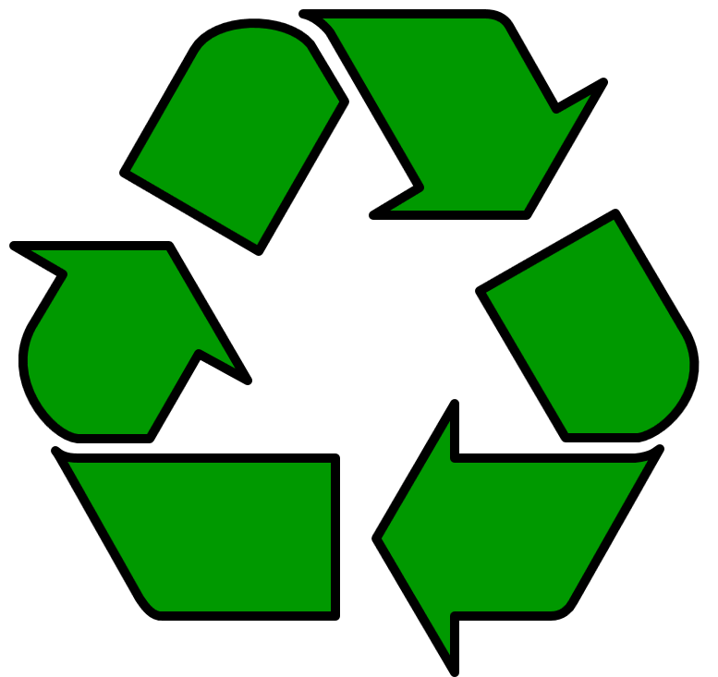

- Although many different types of materials can be recycled for use again (aluminum, glass, plastic, etc.) we are going to focus on paper today and you’ll soon find out why! Ask them to get a piece of paper and look at it closely. Ask if anyone knows what paper is made of? It is made from the bark of trees! The bark is turned into paper for us to write on, color, type on, etc. Paper is a wonderful product for us BUT hundreds of thousands of trees are cut down each year to make paper items for us! What is wrong with this? Many animals live in and around the trees that are being cut down and trees keep our air clean and make the oxygen that we breathe! Yikes! What can you do so less trees are cut down? There are 2 things you can do:
- We can use both sides of our paper! Sometimes we throw paper out and start with a new piece when we make a mistake. We don’t need to though, because that is what erasers and the back sides of paper are for!
- We can recycle paper! We can sort our paper into designated containers and take it to a recycling factory so that it can be made into new sheets of paper or into paper towels and toilet paper! Toilet paper is one type of paper we don’t need to recycle but we can make a choice to use as little as possible! If we keep recycling what we already have, a lot less trees will be cut down and more animal homes will be saved!

Call to Action: Hand out an enlarged picture of one of the animal drawings from the handout titled Please Save the Trees to each child to color. Make 2-3 copies of each animal if needed or find clip art of additional animals that live in a forest (deciduous or rainforest).

Decorate your bulletin board or large poster with large trees and the colored animal drawings and have the students write the names of the animals beneath their drawings. Add the title: We are Saving Trees and these Animals’ Homes by RECYCLING and Using Both Sides of our Paper!

Then have a sign-up sheet and writing utensil attached to the bulletin board where each student will sign his/her name agreeing to reuse and recycle. Write above the sign-in sheet: “If you pledge to do the same, don’t be shy and sign your name!” Explain what a commitment is. If you use a bulletin board in a high traffic area, others will be encouraged to join you and it will catch on!

Follow-Up with the handout titled Please Save the Trees to reinforce the lesson.

Provide a recycling box to each classroom that decides to “sign-on” with you! You can get these donated by grocery stores, the maintenance department, etc. Create a schedule for collecting and weighing the paper. Record data and graph the # of pounds collected each month. Report the results at an end of the year celebration! Pat yourselves on the back for saving trees and animals’ homes!

Reading: Visit our section entitled Recommended Children’s Literature for a comprehensive listing of animal-related books.

Web sites:
www.kidsplanet.org
www.environmentalconcerns.org
www.niehs.nih.gov/kids/home.htm
www.epa.gov/kids/
www.kidsface.org
www.greenpeace.org
www.ikecoalition.org
www.dnr.state.wi.us/org/caer/ce/eek/
Visit our section entitled Recommended Web Links for additional animal-related web sites.

